**Data Visualization and Inference Modeling-The Case of Nifty**

CAPSTONE PROJECT REPORT

By

A Harshith 21R11A0504

P Rohith 21R11A0537

G Harshit 21R11A0519

G Pranav 21R11A0515

D Nissi 21R11A0511



**Department of Computer Science and Engineering**

**Accredited by NBA**

**Geethanjali College of Engineering and Technology**

**(UGC Autonomous)**

(Affiliated to J.N.T.U.H, Approved by AICTE, New Delhi)

Cheeryal (V), Keesara (M), Medchal.Dist.-501 301

March 2024

**ABSTRACT**

This dataset offers a detailed record of the monthly and annual returns of a specific stock spanning from the year 2000 to 2023. It provides investors, financial analysts, and researchers with valuable insights into the historical performance of the stock over an extensive time horizon. Each entry in the dataset contains monthly returns for every year, along with the aggregated annual return. This comprehensive dataset serves as a foundation for in-depth analysis and exploration of the stock's behavior, volatility, and trends over the past two decades. **TABLE OF CONTENTS**

|  |  |  |
| --- | --- | --- |
| **S No** | **Title** | **Page No** |
|  | **ABSTRACT** | 2 |
| **1** | **INTRODUCTION** | 4 |
| **2** | **PROBLEM STATEMENT** | 5 |
| **3** | **OBJECTIVES** | 6 |
|  | 3.1 Existing Methods | 7 |
|  | 3.2 Proposed Methods | 7 |
| **4** | **METHODOLOGY** | 8 |
|  | 4.1 Data Source | 8 |
|  | 4.2 Exploratory data analysis | 9 |
|  | 4.3 Nifty | 26 |
| **5** | **Final Implementation** | 27 |
| **6** | **Conclusion** | 30 |
| **7** | **Future Scope** | 31 |

1. **INTRODUCTION**

Understanding the historical performance of a stock is fundamental for making informed investment decisions and assessing its potential as part of a diversified portfolio. The dataset presented here fills a crucial gap by offering a detailed overview of the monthly and annual returns of a specific stock from 2000 to 2023. This dataset is particularly valuable for investors, financial analysts, and researchers seeking to analyze the stock's performance, identify trends, and evaluate its risk-return profile.

The dataset's time span of over two decades provides a rich source of data for conducting comprehensive analysis and drawing meaningful insights. By examining monthly returns, stakeholders can assess the stock's volatility, identify seasonal patterns, and gauge its sensitivity to market fluctuations. Additionally, the dataset's inclusion of annual returns allows for a broader perspective on the stock's performance over longer timeframes, facilitating comparisons with industry benchmarks and market indices.

Researchers and analysts can leverage this dataset to explore various aspects of the stock's behavior and performance. This may include investigating the impact of macroeconomic factors, industry dynamics, and company-specific events on the stock's returns. Furthermore, the dataset enables the identification of key turning points, anomalies, and trends in the stock's price movements over time.

Ultimately, this dataset serves as a valuable resource for stakeholders looking to conduct empirical research, build predictive models, or develop investment strategies based on historical data. By leveraging the insights derived from this dataset, investors can make more informed decisions, manage risk effectively, and optimize their investment portfolios for long-term growth and stability.

**2. PROBLEM STATEMENT**

This project undertakes a comprehensive analysis of 20 years of Nifty stock market data, with a particular focus on the tumultuous year of 2020 marked by the COVID-19 pandemic. The primary objective is to discern patterns, trends, and anomalies within the monthly and yearly returns of the Nifty index. By meticulously scrutinizing historical data, the analysis aims to unearth valuable insights into market behavior, performance drivers, and investor sentiment during periods of heightened uncertainty.

Through statistical visualization techniques and Python programming, the project seeks to create visual representations such as heat maps and histograms to elucidate the distribution and variation of returns over time. By providing a nuanced understanding of historical market dynamics, this analysis aims to equip stakeholders with actionable insights for making informed investment decisions and crafting effective portfolio management strategies.

Ultimately, the project endeavors to empower stakeholders, including investors, financial analysts, and businesses, with the knowledge and tools necessary to navigate the complexities of the stock market landscape and capitalize on opportunities while mitigating risks.

**3. OBJECTIVES**

1. Historical Performance Analysis: Conduct a comprehensive analysis of the stock's historical performance by examining monthly and yearly returns. Identify key trends, patterns, and anomalies in the data to understand the stock's behavior over time.
2. Volatility Assessment: Evaluate the volatility of the stock by analyzing the variability in monthly returns. Assess the risk associated with investing in the stock and its potential impact on investment portfolios.
3. Correlation Analysis: Investigate the relationship between monthly returns and annual returns to determine the consistency of the stock's performance over different time scales. Identify any correlations or divergences between short-term and long-term returns.
4. Factor Identification: Explore potential factors influencing the stock's returns, such as macroeconomic indicators, industry-specific trends, and company-specific events. Analyze how these factors contribute to fluctuations in monthly and yearly returns.
5. Risk-Return Tradeoff: Assess the risk-return tradeoff associated with investing in the stock. Evaluate whether the potential returns justify the level of risk involved and compare the stock's performance to relevant benchmarks and market indices.
6. Investment Outlook: Provide insights into the investment outlook for the stock based on its historical performance and future prospects. Consider factors such as industry trends, competitive positioning, and growth potential to assess the stock's attractiveness as an investment opportunity.

**3.1 Existing Methods:**

Previous studies and approaches to analyzing stock market data have typically involved statistical analysis, time series modeling, and data visualization techniques. Statistical methods such as mean, standard deviation, and correlation analysis have been commonly employed to understand the central tendency and variability of stock returns. Time series models, including autoregressive integrated moving average (ARIMA) and GARCH models, have been utilized to forecast future stock prices based on historical data patterns.

Data visualization techniques play a crucial role in presenting insights from stock market data effectively. Heat maps, line charts, and histograms are commonly used to visualize trends, patterns, and distributions in stock returns over time. Additionally, machine learning algorithms have been increasingly applied to analyze stock market data, including classification algorithms for predicting market trends and clustering algorithms for segmenting stocks based on similarities in their price movements.

However, despite these existing methods, the unique challenges posed by events such as the COVID-19 pandemic warrant a fresh analysis approach to understand how the market responded to unprecedented disruptions. This project aims to leverage existing methods while focusing on the specific context of the Nifty stock market data, with a particular emphasis on the year 2020, to extract novel insights and inform investment decisions effectively.

**3.2 Proposed methods:**

The project will begin with thorough data preprocessing to cleanse the dataset, handling missing values and outliers while ensuring data uniformity through normalization. Exploratory data analysis (EDA) will visualize monthly and yearly returns distributions, identifying correlations and trends, especially during the critical period of 2020. Various machine learning models, such as linear regression and ensemble methods, will be experimented with for predicting annual returns based on monthly data.A Flask web application will be developed to provide users with an intuitive interface for inputting monthly returns, enabling backend processing to make predictions and display results. Deployment will follow rigorous testing, ensuring reliability, accuracy, and user-friendliness. Feedback from users will guide iterative improvements to enhance the application's effectiveness in providing valuable insights for informed investment decisions and portfolio management strategies.

**4. METHODOLOGY**

**4.1 Data Source**

The data sources are the datasets given. The information in the datasets are related to information related to the monthly reverse .

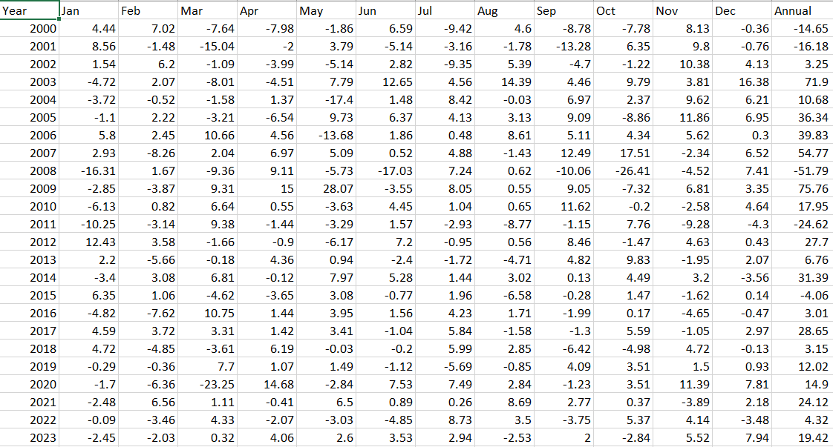

The provided dataset consists of yearly and monthly returns of the Nifty index from the year 2000 to 2023. Each row represents a year, with monthly returns recorded for January through December, along with the annual return for that year.

Yearly returns indicate the overall performance of the Nifty index for each respective year, while monthly returns offer insights into the index's performance on a month-to-month basis. Positive returns indicate growth or profitability, while negative returns suggest losses or declines in value.

For instance, in 2020, the Nifty index experienced significant volatility, with notable monthly returns including a sharp decline of -23.25% in March amidst the COVID-19 pandemic, followed by a recovery with positive returns in subsequent months. The annual return for 2020 is recorded as 14.9%, reflecting the overall performance of the Nifty index for that year.

This dataset serves as valuable input for analyzing trends, patterns, and correlations in Nifty index returns over time, particularly during significant events like the COVID-19 pandemic. It provides essential insights for investors and analysts to understand market behavior, assess risk, and inform investment decisions.

**Exploratory Data Analysis**

Exploratory Data Analysis (EDA) plays a vital role as the initial step in the machine learning workflow. Its primary objective is to thoroughly examine and understand the properties of the data before diving into modeling activities. Through EDA, analysts aim to uncover essential characteristics of the data, such as distribution, correlations between variables, and any noticeable patterns or anomalies. This preliminary exploration is crucial as it provides deep insights into the dataset, enabling informed decisions regarding feature manipulation, data preprocessing, and model selection.

By conducting EDA, researchers can identify and address any missing or erroneous data, outliers, or inconsistencies, thus establishing a more robust foundation for subsequent machine learning tasks.

* **Information about the Features & their data types**

Column No.1: Year, Data Type: int64

Column No.2: Jan, Data Type: float64

Column No.3: Feb, Data Type: float64

Column No.4: Mar, Data Type: float64

Column No.5: Apr, Data Type: float64

Column No.6: May, Data Type: float64

Column No.7: Jun, Data Type: float64

Column No.8: Jul, Data Type: float64

Column No.9: Aug, Data Type: float64

Column No.10: Sep, Data Type: float64

Column No.11: Oct, Data Type: float64

Column No.12: Nov, Data Type: float64

Column No.13: Dec, Data Type: float64

Column No.14: Annual, Data Type: float64

The dataset consists of 14 columns.

Column No.1 represents the year and is of integer data type.

Columns No.2 to No.13 represent the months from January to December, each of float64 data type.

Column No.14 represents the annual data and is also of float64 data type.

**Checking for Data Consistency**

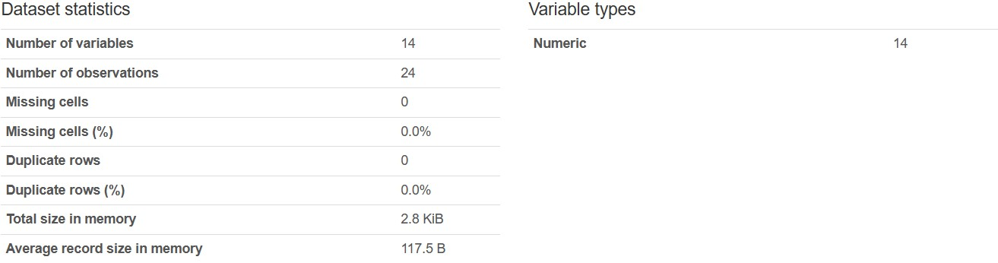

The dataset consists of 14 numeric variables and encompasses 24 observations. There are no missing values or duplicate rows present in the dataset. In terms of memory usage, the dataset occupies 2.8 KiB, with an average record size of 117.5 bytes.

Year

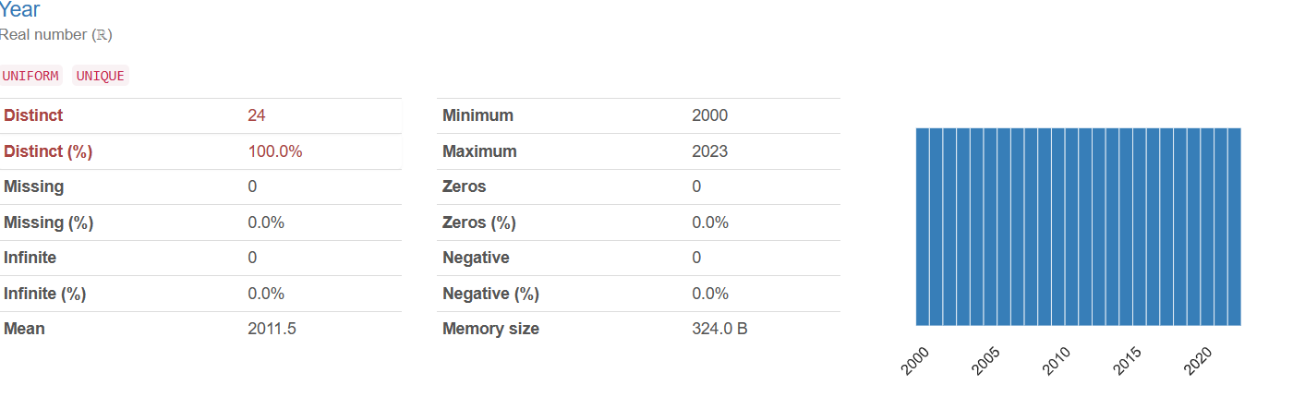

The "Year" variable comprises real numbers (ℝ) spanning uniformly from 2000 to 2023, with 24 distinct values encompassing the entire range. No missing, infinite, zero, or negative values are present in this variable. The mean value of the "Year" variable is 2011.5, and its memory size is 324.0 bytes.

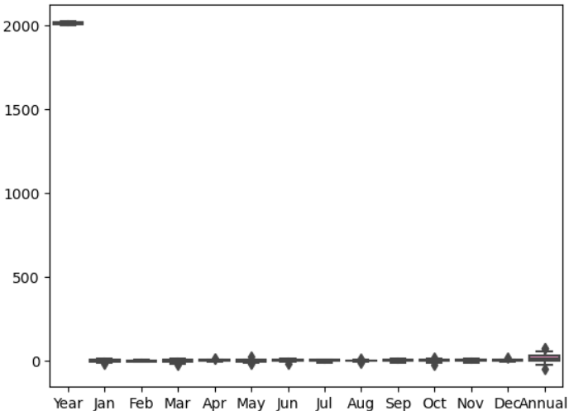

1. The x-axis denotes months of the year from January to December, with additional labels for "Year" and "Annual."
2. The x-axis denotes months of the year from January to December, with additional labels for "Year" and "Annual."
3. A boxplot, also known as a box and whisker plot, is a graphical representation used in exploratory data analysis to depict the distribution of numerical data and identify skewness. Here's how to interpret a boxplot:
   * Minimum Score: The lowest score (excluding outliers) is displayed at the end of the left whisker.
   * Lower Quartile (Q1): Twenty-five percent of scores fall below this value.
   * Median (Q2): The midpoint of the data, dividing the box into two equal parts.
   * Upper Quartile (Q3): Seventy-five percent of scores fall below this value.
   * Maximum Score: The highest score (excluding outliers) is shown at the end of the right whisker.
   * Whiskers: Represent scores outside the middle 50% of data.
   * Interquartile Range (IQR): The range between Q1 and Q3, indicating the middle 50% of scores.
4. Interpretation:
   * The annual summary data is noticeably higher than the monthly data, suggesting a significant increase or accumulation over time.
   * The absence of boxes for individual months implies that their data points may be more concentrated or less variable compared to the annual data.
5. Observations:
   * A distinct marker is visible at the "Year" label on the x-axis, reaching up to 2000 on the y-axis.
   * Black markers are present at each month, although their significance remains unclear without further context.

**Correlation Matrix**

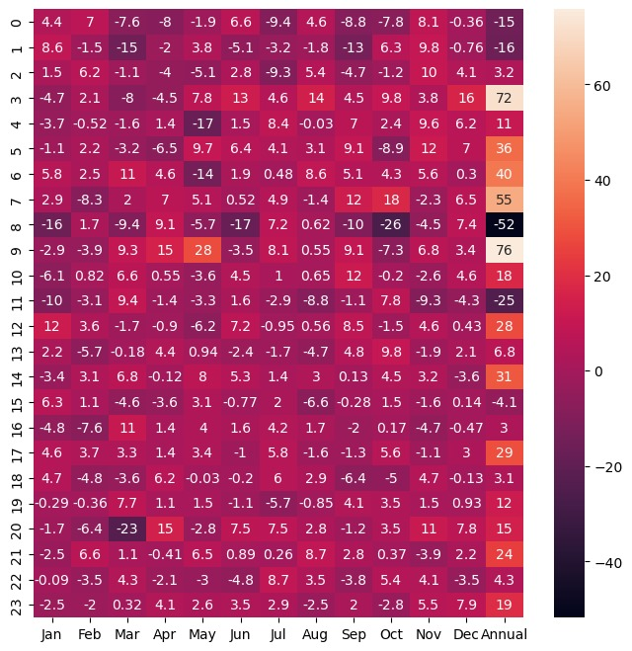

1. The graph illustrates annual returns spanning from 2000 to 2023. Here are key observations based on the data:
   * Returns display high volatility, characterized by notable peaks and troughs throughout the years.
   * Notable Peaks:
     + 2001: Returns nearly reached +80%.
     + 2005: Another peak year with significant positive returns.
     + 2010: Another year marked by strong performance.
   * Significant Troughs:
     + 2002: Returns experienced a significant drop, nearing -40%.
     + 2008: A challenging year with substantial negative returns.
     + 2011: Another year demonstrating poor performance.
   * Since approximately 2012, volatility has decreased, and returns have exhibited moderate fluctuations around the zero mark.
2. Annual return serves as a critical metric for assessing investment profitability and growth. It encompasses both capital appreciation and income received during a specific year, enabling investors to evaluate portfolio performance or individual assets within a defined timeframe.
3. Various methods can calculate annual returns, including:
   * Simple Annual Return: Computed by subtracting the beginning value from the ending value, dividing by the beginning value, and multiplying by 100.
   * Compound Annual Growth Rate (CAGR): Adjusts for compounding interest and provides a comprehensive depiction of returns over time.
   * Total Return: Accounts for both capital gains and income received during the year.

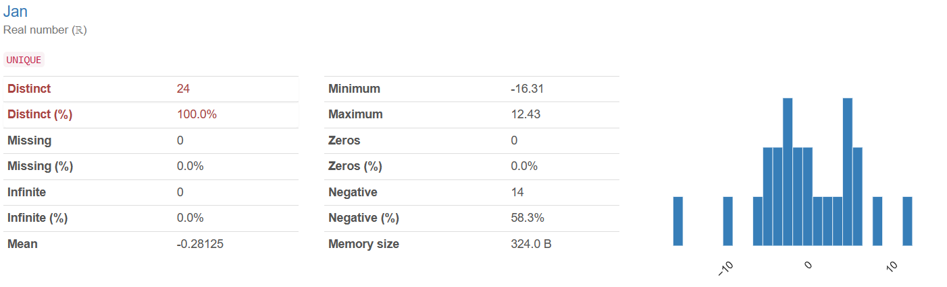

The "Jan" variable comprises real numbers (ℝ) with 24 distinct values spanning the entire range. No missing or infinite values are present. The mean value is -0.28125, with a minimum of -16.31 and a maximum of 12.43. Although there are no zero values, 14 values are negative, accounting for 58.3% of the dataset. The memory size occupied by this variable is 324.0 bytes.

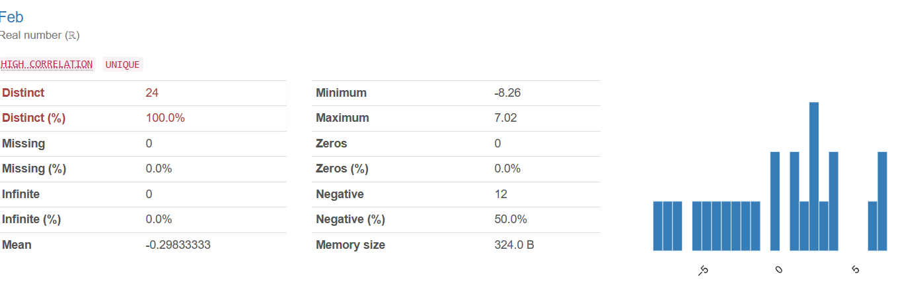

The "Feb" variable comprises real numbers (ℝ) with a high correlation, and all 24 values are distinct. No missing or infinite values are present. The mean value is -0.29833333, ranging from a minimum of -8.26 to a maximum of 7.02. While there are no zero values, 12 values are negative, constituting 50.0% of the dataset. The memory size occupied by this variable is 324.0 bytes.

Top of Form

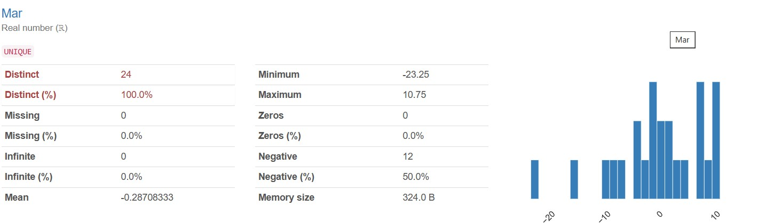

The "Mar" variable comprises real numbers (ℝ), with all 24 values being distinct. No missing or infinite values are present. The mean value is -0.28708333, ranging from a minimum of -23.25 to a maximum of 10.75. While there are no zero values, 12 values are negative, constituting 50.0% of the dataset. The memory size occupied by this variable is 324.0 bytes.

Top of Form

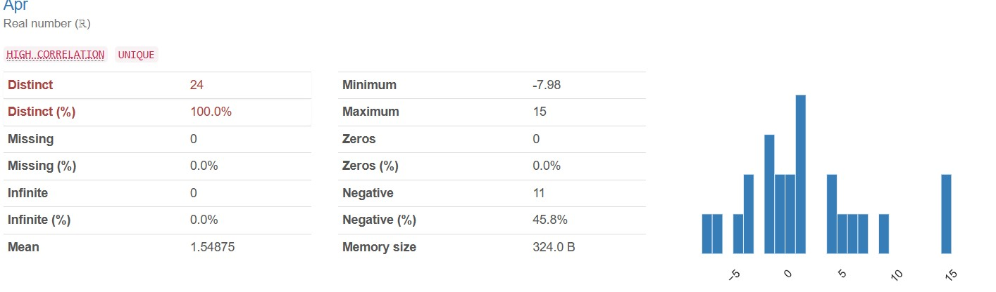

The "Apr" variable comprises real numbers (ℝ) with a strong correlation, and all 24 values are distinct. No missing or infinite values are present. The mean value is 1.54875, ranging from a minimum of -7.98 to a maximum of 15. Although there are no zero values, 11 values are negative, making up 45.8% of the dataset. The memory size occupied by this variable is 324.0 bytes.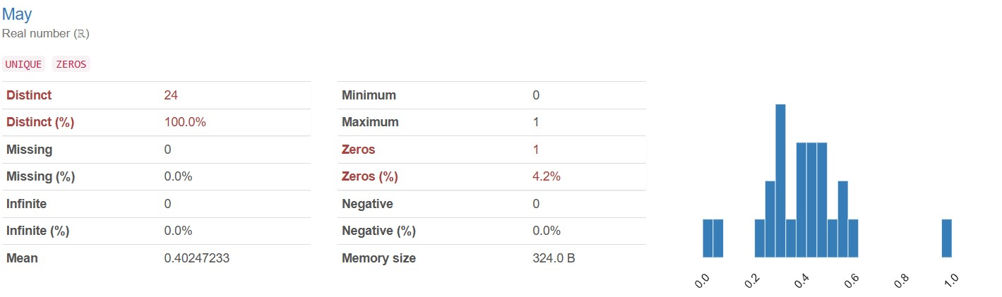

The "May" variable comprises real numbers (ℝ), with all 24 values being distinct. No missing or infinite values are present. The mean value is 0.40247233, ranging from a minimum of 0 to a maximum of 1. A single zero value is present, accounting for 4.2% of the dataset. There are no negative values. The memory size occupied by this variable is 324.0 bytes.

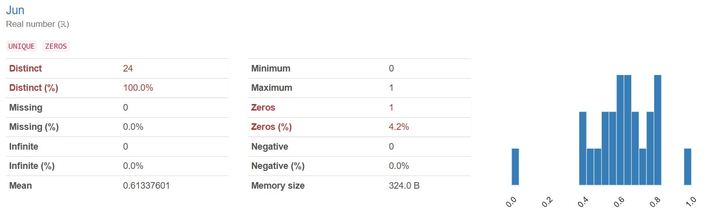

The "Jun" variable consists of real numbers (ℝ), with all 24 values being distinct. There are no missing or infinite values. The mean value is 0.61337601, ranging from a minimum of 0 to a maximum of 1. A single zero value is present, representing 4.2% of the dataset. There are no negative values. The memory size occupied by this variable is 324.0 bytes.

Top of Form

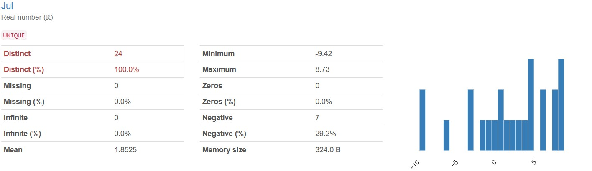

The "Jul" variable comprises real numbers (ℝ), with all 24 values being distinct. No missing or infinite values are present. The mean value is 1.8525, ranging from a minimum of -9.42 to a maximum of 8.73. While there are no zero values, 7 values are negative, constituting 29.2% of the dataset. The memory size occupied by this variable is 324.0 bytes.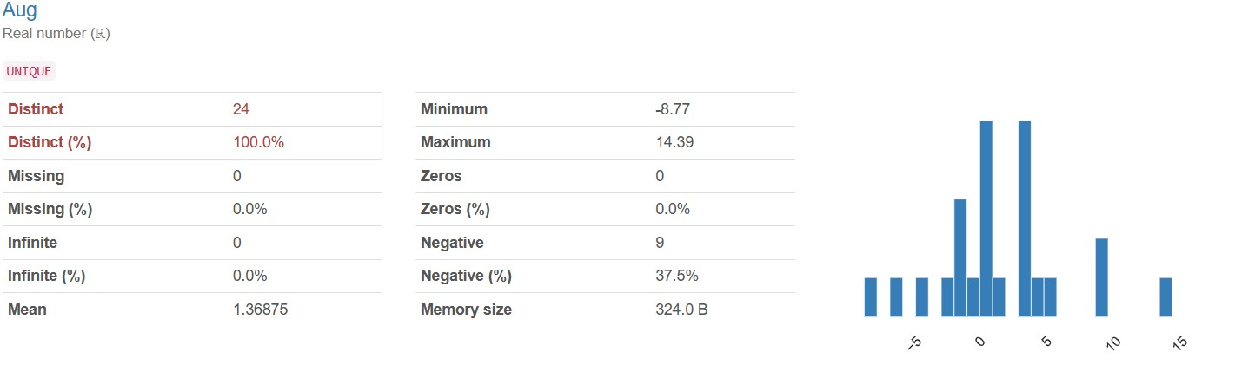

The "Aug" variable consists of real numbers (ℝ), with all 24 values being distinct. No missing or infinite values are present. The mean value is 1.36875, ranging from a minimum of -8.77 to a maximum of 14.39. While there are no zero values, 9 values are negative, making up 37.5% of the dataset. The memory size occupied by this variable is 324.0 bytes.

Top of Form

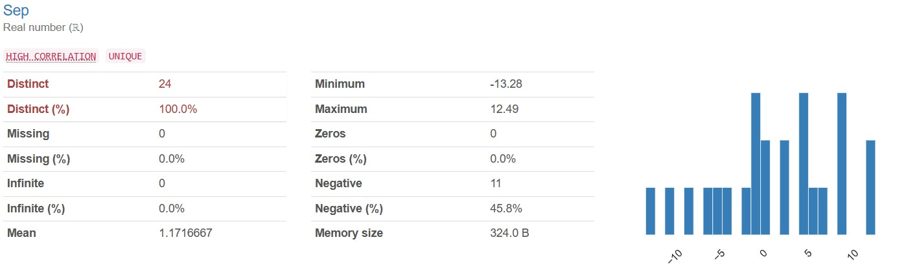

The "Sep" variable comprises real numbers (ℝ) with a strong correlation, and all 24 values are distinct. No missing or infinite values are present. The mean value is 1.1716667, ranging from a minimum of -13.28 to a maximum of 12.49. While there are no zero values, 11 values are negative, making up 45.8% of the dataset. The memory size occupied by this variable is 324.0 bytes.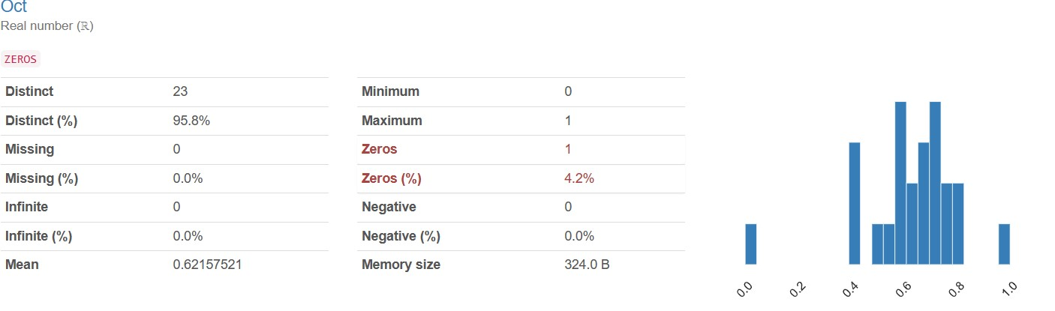

The "Oct" variable is composed of real numbers (ℝ), with 23 distinct values encompassing 95.8% of the dataset. There are no missing or infinite values. The mean value is 0.62157521, ranging from a minimum of 0 to a maximum of 1. A single zero value is present, representing 4.2% of the dataset. No negative values are observed. The memory size occupied by this variable is 324.0 bytes.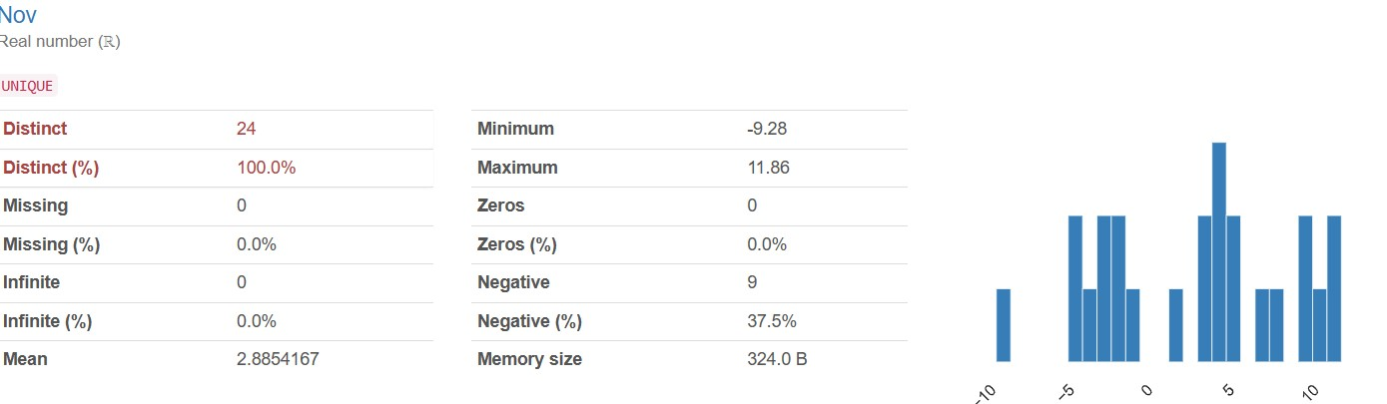

The "Nov" variable consists of real numbers (ℝ), with all 24 values being distinct. No missing or infinite values are present. The mean value is 2.8854167, ranging from a minimum of -9.28 to a maximum of 11.86. While there are no zero values, 9 values are negative, making up 37.5% of the dataset. The memory size occupied by this variable is 324.0 bytes.

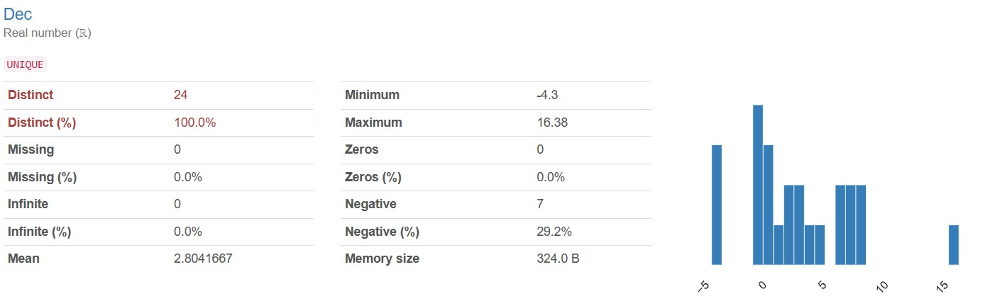

The "Dec" variable comprises real numbers (ℝ), with all 24 values being distinct. No missing or infinite values are present. The mean value is 2.8041667, ranging from a minimum of -4.3 to a maximum of 16.38. Although there are no zero values, 7 values are negative, making up 29.2% of the dataset. The memory size occupied by this variable is 324.0 bytes.

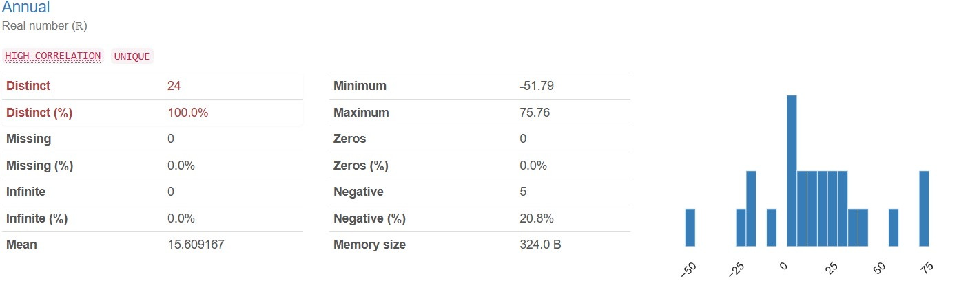

The "Annual" variable consists of real numbers (ℝ) with a strong correlation, and all 24 values are distinct. No missing or infinite values are present. The mean value is 15.609167, ranging from a minimum of -51.79 to a maximum of 75.76. While there are no zero values, 5 values are negative, constituting 20.8% of the dataset. The memory size occupied by this variable is 324.0 bytes.

**Distribution Of Monthly Returns**

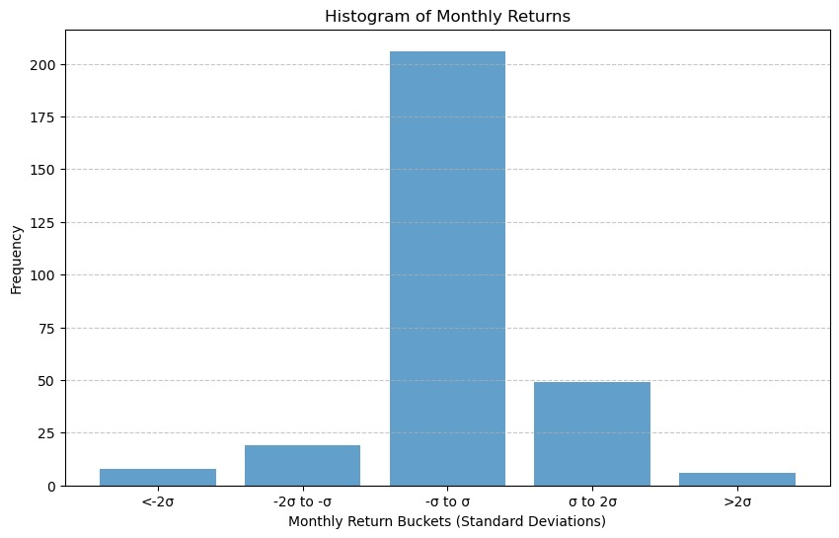

1. The heatmap illustrates monthly returns spanning 22 years. Each cell's color intensity signifies the return value, with red denoting negative returns and blue representing positive returns.
2. Observations from the heatmap include:
   * January (Jan): Returns at -4.44%.
   * February (Feb): Positive return of 7.02%.
   * March (Mar): Strong performance with returns at -7.98%.
   * April (Apr): Another positive month, returning 0.34%.
   * May: Modest return of 0.80%.
   * June (Jun): Slightly better at -9.42%.
   * July (Jul): Impressive return of 4.60%.
   * August (Aug): Decent performance with returns at -8.78%.
   * September (Sep): Robust return at 8.13%.
   * October (Oct): Small positive return of 0.76%.
   * November (Nov): Strong month with returns at 8.56%.
   * December (Dec): Another modest return of -1.48%.
3. The heatmap's color variations depict fluctuations in monthly returns across the years.

**Yearly Annual Returns**

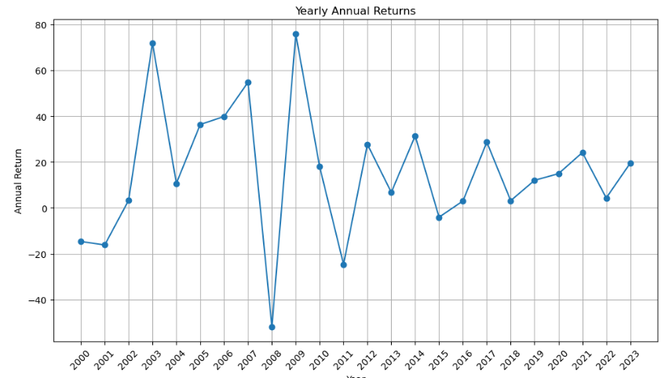

1. The graph illustrates annual returns spanning from 2000 to 2023. Key observations include:
   * High volatility in returns, characterized by significant peaks and troughs over the years.
   * Notable peaks observed in 2001, 2005, and 2010, indicating strong positive performance.
   * Significant troughs noted in 2002, 2008, and 2011, indicating periods of poor performance.
   * Since around 2012, volatility has decreased, with returns fluctuating moderately around the zero mark.
2. Annual return serves as a crucial metric for assessing investment profitability and growth. It encompasses both capital appreciation and dividends or income received during a specific year, enabling investors to evaluate portfolio performance within a defined timeframe.
3. Various methods exist for calculating annual returns, including:
   * Simple Annual Return: Calculated by subtracting the beginning value from the ending value, dividing by the beginning value, and multiplying by 100.
   * Compound Annual Growth Rate (CAGR): Adjusts for compounding interest and offers a comprehensive view of returns over time.
   * Total Return: Considers both capital gains and income received during the year, providing a holistic assessment of investment performance.

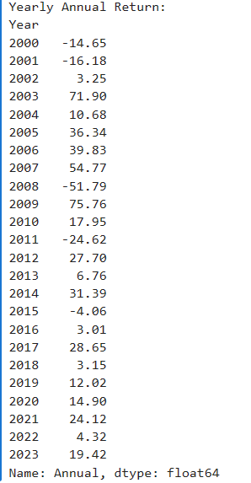

The dataset presents yearly annual return percentages spanning from 2000 to 2023. Returns vary from a minimum loss of -51.79% in 2008 to a maximum gain of 75.76% in 2009. Notable years include 2003, showing a gain of 71.90%, 2007 with a gain of 54.77%, and 2011 with a loss of -24.62%. Positive values denote gains, while negative values indicate losses.

Top of Form

**Distribution Of Yearly Returns**

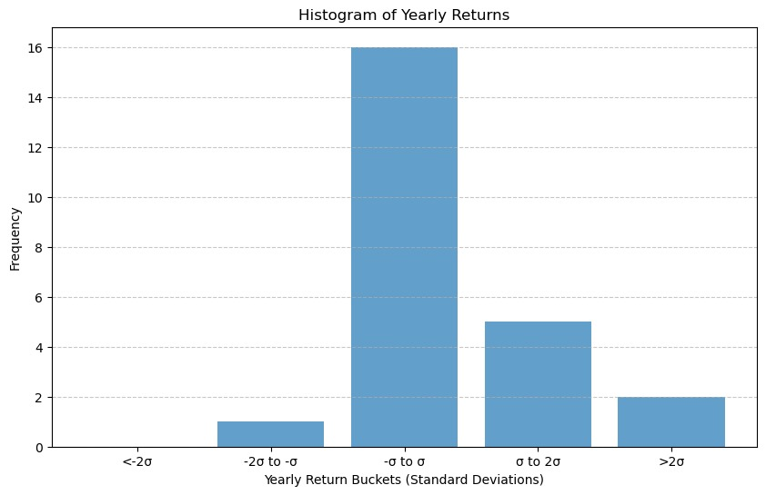

1. The histogram illustrates the distribution of yearly returns over a specific timeframe. Here are the main observations:
   * The x-axis represents yearly return percentages, spanning from -40% to 60%.
   * The y-axis indicates frequency, showing the occurrence of each return value.
   * The histogram demonstrates the clustering of data points around the mean yearly return, depicted by the solid red line.
   * Additionally, two standard deviation lines are visible:
     + +1 standard deviation (green dashed line) and -1 standard deviation (green dashed line) from the mean.
     + +2 standard deviations (yellow dashed line) and -2 standard deviations (yellow dashed line) from the mean.
2. Key insights:
   * The majority of data points lie within one standard deviation from the mean.
   * The distribution appears to be approximately symmetric, with a peak observed around the mean return of 0%.
   * As we move farther from the mean, the spread of returns widens.
3. It's important to recognize that comprehending the distribution of returns is vital for assessing risk and optimizing portfolios.

**4.2 Nifty Methodology**:

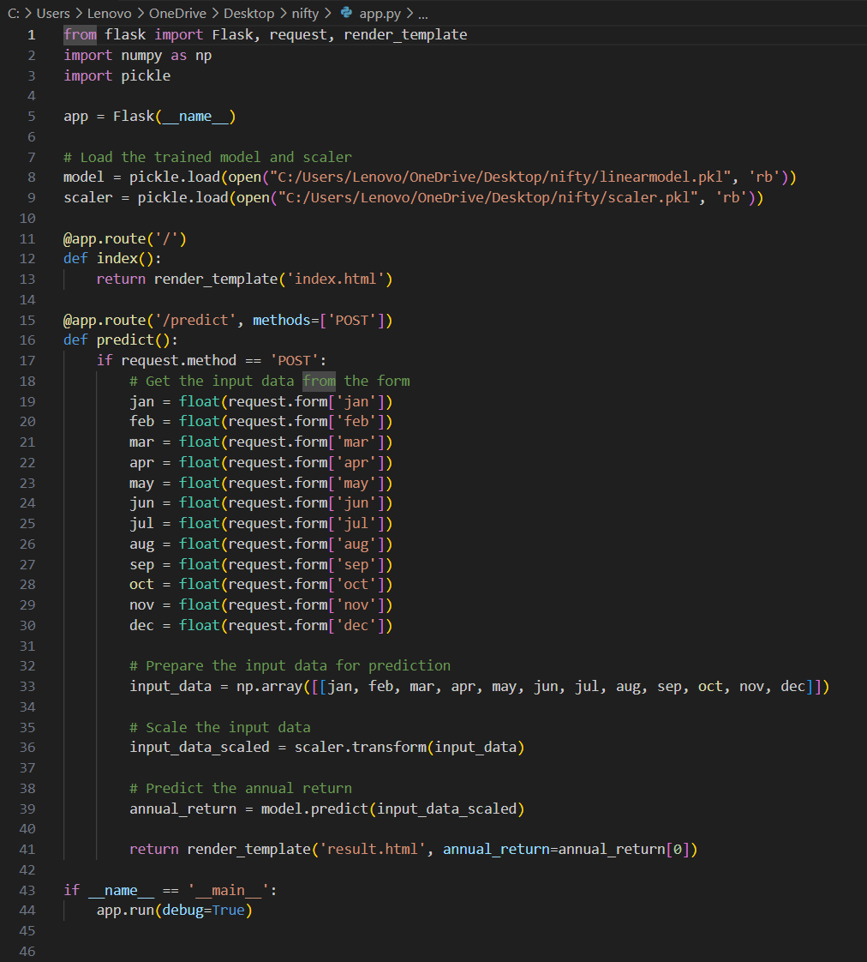

This Flask web application acts as an interface for estimating yearly returns based on user-input monthly returns. It uses a trained machine learning model and a scaler for data preparation.   
  
The 'index.html' file offers a form where customers may enter their monthly returns. Once submitted, the data is sent to the Flask server for processing.  
  
  
The Flask server loads the trained model and scaler from the pickle files that have been stored. After receiving the input data, it preprocesses it by scaling it using the loaded scaler before making predictions with the trained model. The estimated yearly return is then sent to the'result.html' template for presentation.

To use the application, make sure you have the appropriate HTML templates ('index.html' and'result.html'), the trained model ('linearmodel.pkl'), and the scaler ('scaler.pkl').   
  
You may start the Flask server by running the script, and then visit the application via a web browser. Users may enter their monthly returns data and obtain the estimated year return as an output.

**5. Final Implementation**

**Flask Application Setup**: The application is built using the Flask micro web framework in Python. It consists of a main script (app.py) defining routes and handling requests.

**Model Loading:** The trained machine learning model (linearmodel.pkl) and the scaler for data preprocessing (scaler.pkl) are loaded using the pickle module.

**User Interface:** The application provides a simple and intuitive user interface using HTML templates (index.html and result.html). The index.html template contains a form for inputting monthly returns, while the result.html template displays the predicted annual return.

**Prediction Endpoint**: The Flask application defines a route ('/predict') to handle POST requests containing the user-input monthly returns data. Upon receiving the data, it preprocesses it using the loaded scaler, makes predictions using the trained model, and renders the result.html template with the predicted annual return.

**Deployment:** The application can be run locally by executing the main script (app.py) and accessing it through a web browser. Additionally, it can be deployed on a server to make it accessible to users over the internet.

1. Launch the web app by executing the Python code, which will deploy the application on localhost.

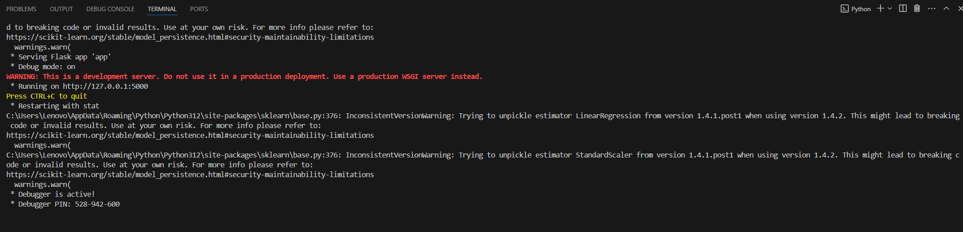

1. Access the deployed web application through a browser. Upon successful deployment, the webpage will be displayed as intended and enter the details and Proceed by clicking the Predict button.

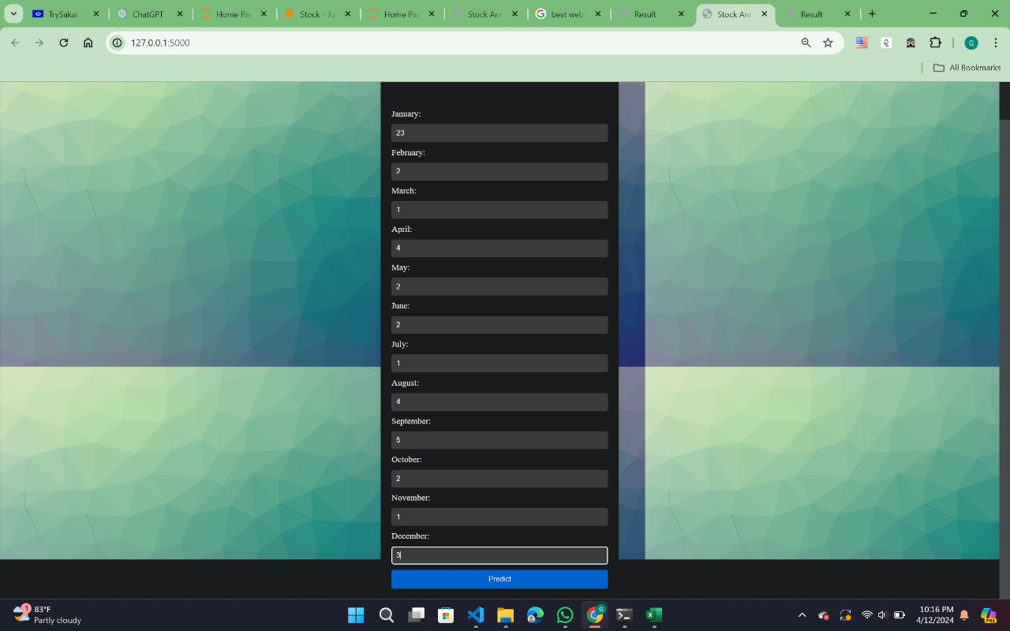

3. You will find the results on the Result Page'.

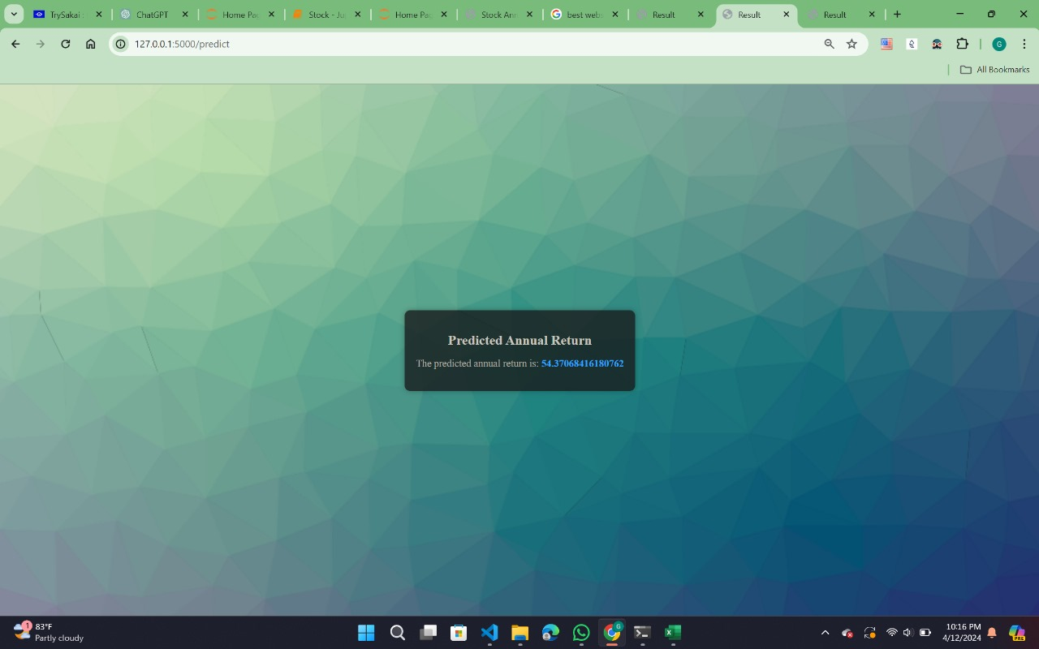

**6. Conclusion**

The final Flask web application solution provides a user-friendly interface for estimating the Nifty index's yearly return using monthly return data. It uses a trained machine learning model and scaler to produce accurate forecasts and provide significant insights to investors and analysts. Further upgrades and enhancements can be implemented in response to user input and changing requirements.

**Future Scope**

1. **Predictive Modeling:** The dataset can be used to develop predictive models that forecast future stock returns based on historical patterns and relevant factors.

2. **Risk Management:** Advanced statistical techniques can be applied to analyze the dataset and develop risk management strategies to mitigate potential losses.

3. **Algorithmic Trading:** By incorporating the dataset into algorithmic trading systems, investors can automate trading decisions based on predefined rules and criteria.

4. **Portfolio Optimization:** Investors can optimize their portfolios by incorporating insights from the dataset to achieve a balance between risk and return.

5. **Market Research:** Researchers can use the dataset to conduct market research and gain insights into investor sentiment, market trends, and competitive dynamics.

6. **Financial Planning:** Financial planners can leverage the dataset to provide personalized investment advice and strategies tailored to individual client goals and risk preferences.